**Issue 1**: Currency sign is missing is the payment amount

**Description**: The currency symbol is not present near the payment amount. See below screenshot

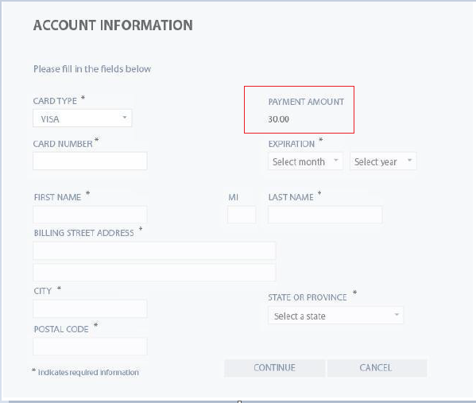

**Expected Behavior**: Currency symbol (like $ or €) should be present near the payment amount

**Severity**: Critical